Yaesu VX-8R out of bank modification

- Take out the battery.
- Under the battery is a heavy, thick plastic cover with very strong adhesive. Remove it using an XActo knife or a very small screwdriver that you can slip under it. This is the same cover you need to lift to install the Bluetooth option.
- After you get the cover open, it will look like this:
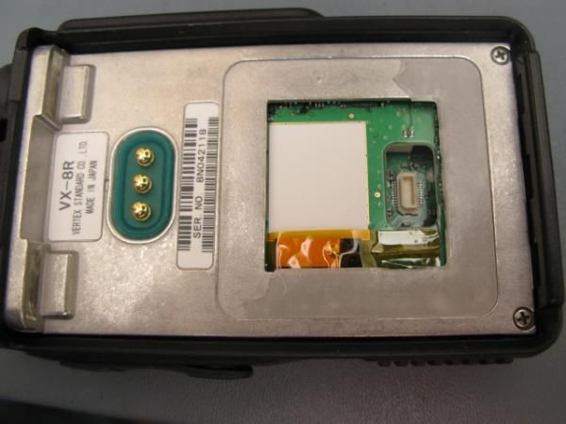
- To mod the radio for out of band TX, locate the only resistor visible on the board, just to the left of the bluetooth plug:
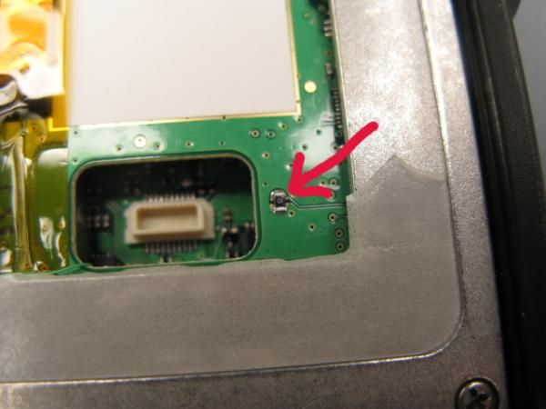
- All you have to do is carefully remove this resistor. I have a fine tip for my solder station for little work like this:
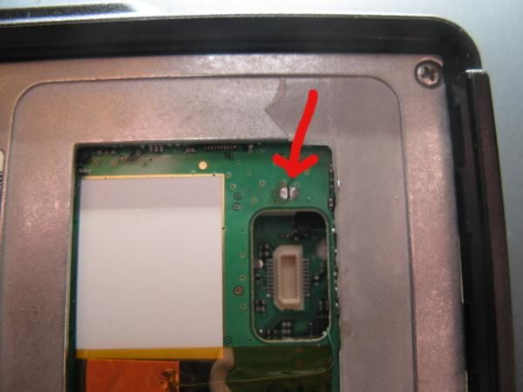
Make sure you clean off ALL the residual adhesive. Don't try to put back the cover that you took off, as it will be badly deformed and you will have lost some of the adhesive. Yaesu gives you several extra covers in the bottom of the box, so use a new one. This is important to preserve the waterproof integrity of the radio!

