Modification for Yaesu FTDX9000

- WRITE DOWN EVERY SETTING IN THE MENU SYSTEM ON PAPER because all of these settings will be lost after 'CPU Reset'
- Disconnect the radio from all power, accessories, and antennas prior to attempting this modification.
- Use a grounded low power thermo control soldering iron.
- Disassemble the radio by taking the two side panels and top cover off. The board that you need to modify is the Control Board which is mounted vertically behind the front panel (but not mounted on the front panel assembly). It is mounted on the chassis.
- Loosen the two screws holding the front panel to the chassis on both sides. Slide the front panel diagonally upward and forward. You may be able to tilt the front panel down to do the mod, but be very careful not to melt wiring.
- The Control Board has a microprocessor chip on it which is mounted diagonally. You will see a row of jumpers JP5001 to JP5012 on the control board between the diagonally mounted processor and the memory backup battery. The jumpers are labeled with white letters. Write down the current configuration of the jumpers (so that you can put the radio back to original condition if you later desire to do so!!!!!)
- For Japanese version. JP5004-5006 are closed (see pic below)
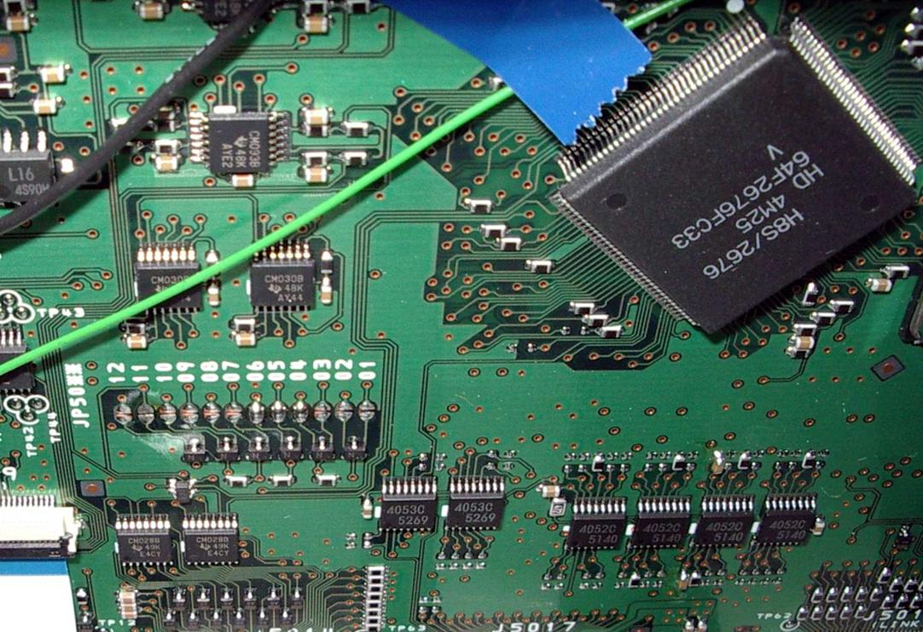
- For US version, all 12 jumpers are opened (see pic below)
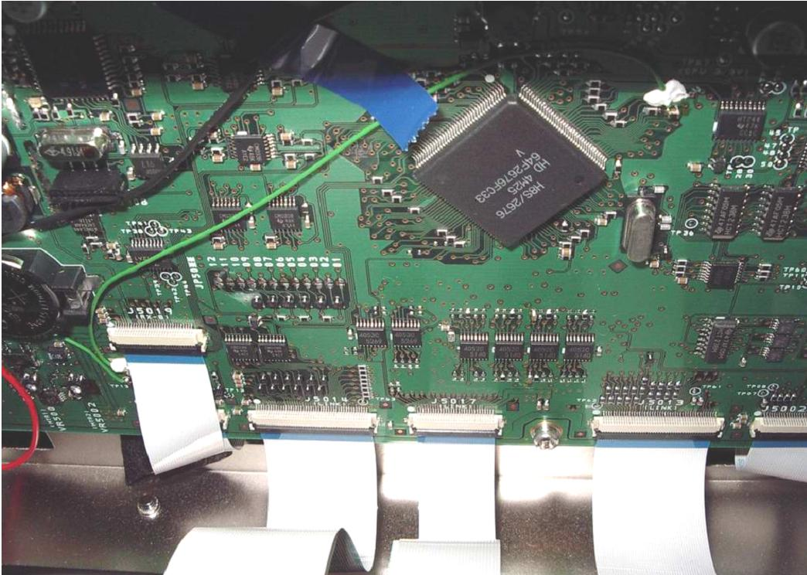
- For MARS modification, add solder bridges to JP5007 and JP5011. JP5011 is the second jumper from the left looking from the front of the radio. Jumper JP5007 is the sixth one in from the left end of the row of jumpers. Make sure that no other jumpers are soldered in. If any other jumpers are filled in, unsolder the bridges on them so that JP5007 and JP5011 are the only two remaining jumpers.
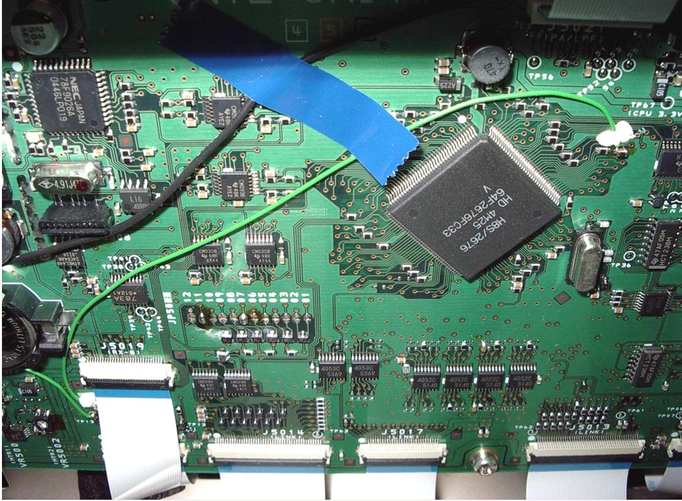
- Reassemble the radio.
- Do a Full Reset by holding the "FAST" and "LOCK" buttons in while pushing the "POWER" switch to ON. The radio will go through it's reinitialization routine.
- Check (into a dummy load) to see if it transmits out of band. Reload all of your menu settings from where you wrote them down, and enjoy your broadband TX FT9000. Read your licence and check whether you are authorized to transmit outside ham bands.
- The TX range is now 1.8-30Mhz and 50-54Mhz.

