FTM-400DR YAESU

New frequecy after the modification:
136-174 mhz RX/TX
400-480 mhz RX/TX
- Open the upper shell (speaker)
- Lithium battery locate the left side
- Identify positive symbol lithium battery
- Remove resistance as photos
Perform as cpu reset page 61
Picture: FTM-400-MOD2.JPG
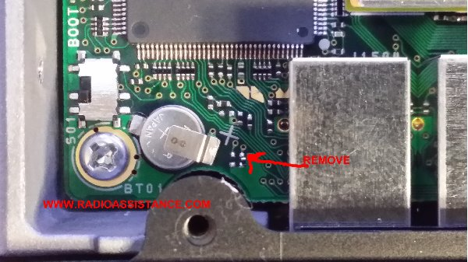
Picture: ftm-400-mod1.JPG
